3.1 – I/O Redirection

“ls > <file>”
The greater than operator when used in the terminal following an output will write to the specified file instead of outputting to the screen. This overwrites any previous text.

“more”
The more command displays to the terminal screen, one page length at a time instead of outputting the entire file at once. This allows for easier viewing when reading larger files.

“ls >> <file>”
The greater-greater than operator when used in conjunction with a command that outputs will append the output to the file specified instead of to the screen without overwriting the contents.

3.2 – Access Permissions
“chmod” - before

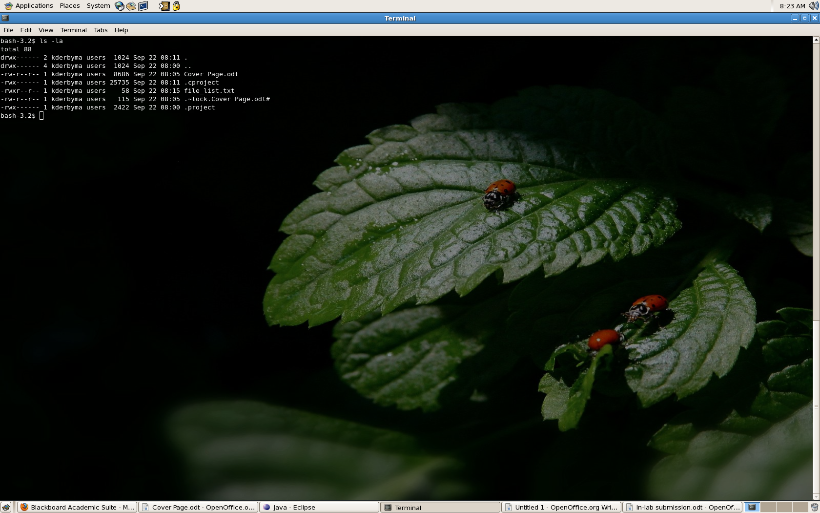
after
